SQL Project: Data Cleaning – World Layoffs Dataset
Objective
The goal of this project is to clean and prepare the world_layoffs dataset for analysis. The raw data contains duplicates, inconsistent formatting, and missing values. By creating a staging table and applying systematic cleaning steps, the dataset becomes reliable and ready for exploratory data analysis (EDA).

Steps in Data Cleaning
1. Create a Staging Table
- A staging table (layoffs_staging) is created as a working copy of the raw dataset.
- This ensures the original data remains untouched while cleaning operations are performed.
2. Remove Duplicates
- Duplicate rows are identified using the ROW_NUMBER() function with partitioning across key columns (company, location, industry, date, etc.).
- Rows with row_num > 1 are considered duplicates and removed.
- A secondary staging table (layoffs_staging2) is created with a row_num column to simplify duplicate removal.
3. Standardize Data
- Industry column:
  - Empty strings are converted to NULL.
  - Missing industries are filled by referencing other rows of the same company.
  - Variations like “CryptoCurrency” and “Crypto Currency” are standardized to “Crypto.”
- Country column:
  - Inconsistencies such as “United States.” (with a trailing period) are corrected using TRIM.
- Date column:
  - Converted from text format to proper DATE type using STR_TO_DATE.
4. Handle Null Values
- Columns such as total_laid_off, percentage_laid_off, and funds_raised_millions retain their null values.
- This approach preserves data integrity and makes calculations during EDA more accurate.
5. Remove Useless Data
- Rows where both total_laid_off and percentage_laid_off are null are deleted, as they provide no analytical value.
- The temporary row_num column is dropped after duplicate removal.

Outcome
After cleaning:
- The dataset is free of duplicates.
- Industry and country values are standardized.
- Dates are properly formatted.
- Irrelevant rows are removed.
This cleaned dataset is now consistent, accurate, and ready for deeper analysis of global layoff trends.

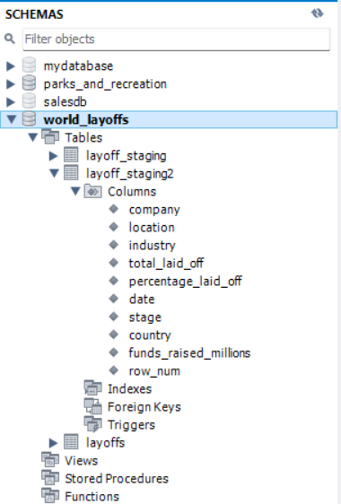

“This schema is the foundation of our cleaned dataset.”
It shows how we moved from raw layoffs data into a structured staging environment.

BY LinkedIN | GitHub

